**Test Document for Buyer field in Payment Request**

Test Document are adding buyer display in tfmsl0520m000 Payment Request.

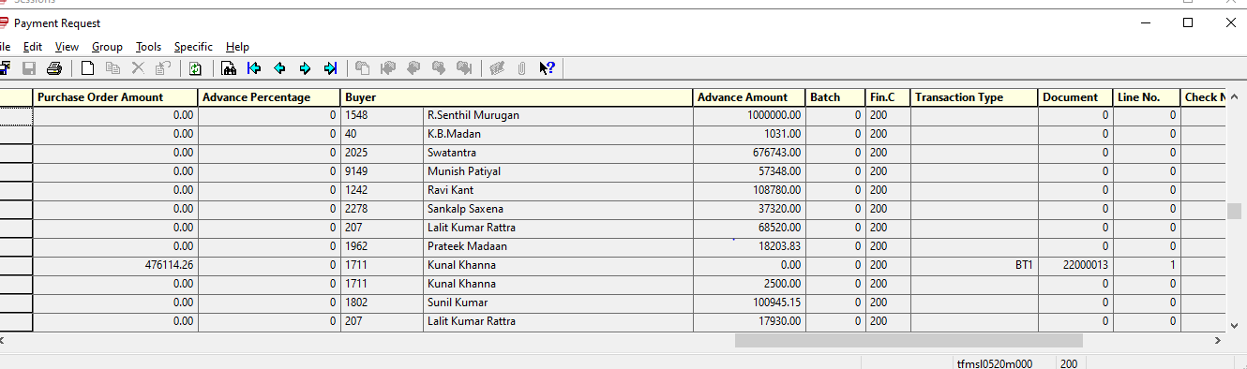

Buyer should be shown from Purchase Order